0000001C8106С303FF03DB03FF03FFFE7EFE18C618C601CE01CE0000
 | 0 | 0
0000000000011100 | 28 | 001C
1000000100000110 | 33030 | 8106
1100001100000011 | 49923 | С303
1111111100000011 | 65283 | FF03
1101101100000011 | 56067 | DB03
1111111100000011 | 65283 | FF03
1111111111111110 | 65534 | FFFE
0111111011111110 | 32510 | 7EFE
0001100011000110 | 6342 | 18C6
0000000011000110 | 6342 | 18C6
0000000111001110 | 462 | 01СЕ
0000000111001110 | 462 | 01СЕ
 | 0 | 0000

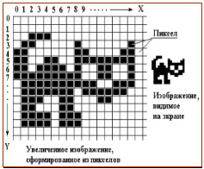
кошечка
0011100000000000 |  | 3800
0110000010000001 |  | 6081
1100000011000011 |  | C0C3
1100110011111111 |  | CCFF
1101111010011001 |  | DE99
1111111110011001 |  | FF99
0111111111100111 |  | 7FE7
0111111101111110 |  | 7F7E
0111001100011000 |  | 7318
0110001100000000 |  | 6300
0111101110000000 |  | 7B80
0111101110000000 |  | 7B80

козлик
0010000001000000 | 8256 | 2040
0001000010000000 | 4224 | 1080
0000111100000000 | 3840 | 0F00
0000111100000000 | 3840 | 0F00
0000111100000000 | 3840 | 0F00
0000011000000001 | 1537 | 0601
0000011111111110 | 2046 | 07FE
0000111111111110 | 2046 | 07FE
0000111111111100 | 4092 | 0FFC
0001101100001110 | 6926 | 1B0E
0001000100001010 | 4362 | 110A
0001000100001010 | 4362 | 110A
 | 0 | 0000
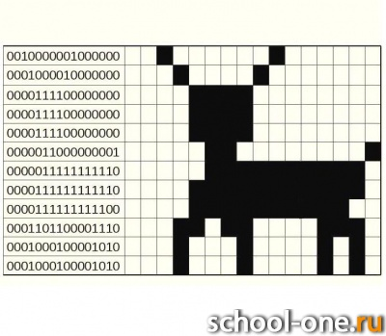

0000001100000000 | 768 | 0300
0000110011000000 | 3264 | 0CC0
0001100001100000 | 6240 | 1860
0010000000010000 | 8208 | 2010
0100000100001000 | 16648 | 4108
0101010000101000 | 21544 | 5428
0100000010001000 | 16520 | 4088
0011000000110000 | 12336 | 3030
0000110011000000 | 3264 | 0CC0
0000001100000000 | 1536 | 0300
0000001100000000 | 1536 | 0300
0000001100000000 | 1536 | 0300
0000001100000000 | 1536 | 0300
0000001100000000 | 1536 | 0300

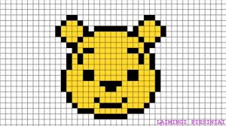
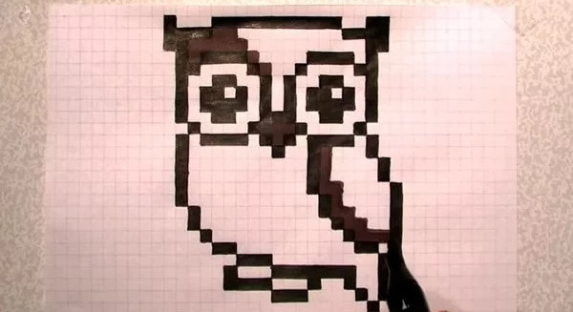
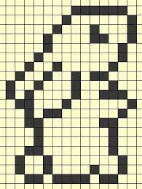

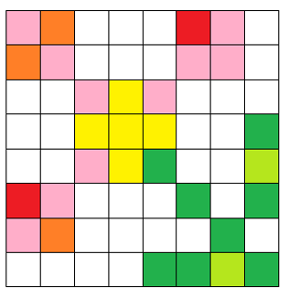
255  174  210 |  | 255  127  39 |  |  |  | 237  205  125 | 255  174  210
255  127  39 |  | 255  174  210 |  |  |  | 255  174  210 | 255  174  210
 |  |  | 255  174  210 | 255  242  0 | 255  174  210
 |  |  | 255  242  0 | 255  242  0 | 255  242  0 |  |  | 34  177  76
 |  |  | 255  174  210 | 255  242  0 | 34  177  76 |  |  | 181  230  29
237  205  125 |  | 255  174  210 |  |  |  | 34  177  76 |  | 34  177  76
255  174  210 |  | 255  127  39 |  |  |  |  | 34  177  76
 |  |  |  |  | 34  177  76 | 34  177  76 | 181  230  29 | 34  177  76

